Calculating with negative gradients

We know how to calculate a positive gradient:-

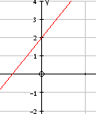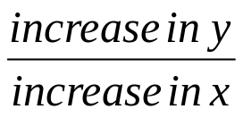

What about if the gradient is negative?
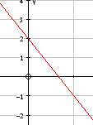
This time the y value is decreasing or negatively increasing. So if it goes down by 2 we use -2 as the increase in y value.

Eg.

Find the gradient of the line connecting (2,4) and (6,-4).

We may want to sketch the points to help
increase in x = 4 (from 2 to 6)
increase in y = -8 (from 4 to -4)

So gradient = -8/4 = -2

